Great Lakes PGPBABI -Hyderabad

WSMA Group assignment: Twitter Data Analysis in R

Group -3 Submission

By

**Ajit Kumar Mishra**

Rajesh Kumar Pandey

**Srikanth Agiru**

**Sundeep Motamari**

Assignment Details

Instructions for each group:

- Identify a brand - any global or Indian product, celebrity, company etc

- For the identified brand download a minimum 1000 twitter messages for the most recent period

- Conduct text mining on the data – Correlation, Frequency, Topic Modelling, Sentiment Analysis

- Submit analysis report and code as part of the assignment – R Markdown document only if using R

- Can leverage any tool for data visualization, text mining, ML etc

- Can expand the source of data to face book or any other source as well, but twitter is a must

- No two groups should have the same brand

Solution

The team decided to use R for analyzing the tweets and get insights from the data. The R markdown file has been added toward the end of this document. Please find the various steps followed by the team.

# 1. Identify a brand - any global or Indian product, celebrity, company etc

To identify an object for analysis, we relied on Google trends to see what is latest matter we can pick up. Here is our finding based on 2 months google trend data for search items – “Aaj Tak”, “Virat Kohli”, “Infosys”, “Ganesh Chaturthi” and “Narendra Modi”.

Although, we are going to analyze Twitter data, we thought, it would be nice to see how our favorite search items trending in web search (Google).

We decided to go with ‘Narendra Modi’, simply because of our inclination toward the PM and his governance.

# 2. Download a minimum 1000 twitter messages for the most recent period

We tried downloading around 5000 recent tweets for Narendra Modi an analyzed it for our assignment. Refer to R code for details.

# 3. Conduct text mining on the data – Correlation, Frequency, Topic Modelling, Sentiment Analysis

Refer to R code for details.

# 4.Submit analysis report and code as part of the assignment – R Markdown document only if using R

Refer to R code for details.

WSMA_Group_Assignment.R

Group # 3

Sat Aug 26 21:03:32 2017

###################################################################################################################################  
# Group Assignent for WSMA  
# Author - PGPBABIH - Group #3  
###################################################################################################################################  
# Clean up and Garbage collection   
rm(list=ls(all=TRUE))  
gc(reset=T)

## used (Mb) gc trigger (Mb) max used (Mb)  
## Ncells 471813 25.2 940480 50.3 471813 25.2  
## Vcells 855689 6.6 1650153 12.6 855689 6.6

###################################################################################################################################  
# Load the required libraries for R code  
###################################################################################################################################  
library(twitteR)

## Warning: package 'twitteR' was built under R version 3.4.1

library(tm)

## Loading required package: NLP

library(ggplot2)

##   
## Attaching package: 'ggplot2'

## The following object is masked from 'package:NLP':  
##   
## annotate

library(ROAuth)

## Warning: package 'ROAuth' was built under R version 3.4.1

library(wordcloud)

## Loading required package: RColorBrewer

library(lubridate)

## Warning: package 'lubridate' was built under R version 3.4.1

##   
## Attaching package: 'lubridate'

## The following object is masked from 'package:base':  
##   
## date

library(data.table)

##   
## Attaching package: 'data.table'

## The following objects are masked from 'package:lubridate':  
##   
## hour, isoweek, mday, minute, month, quarter, second, wday,  
## week, yday, year

library(SnowballC)  
library(syuzhet)

## Warning: package 'syuzhet' was built under R version 3.4.1

library(stringr)  
  
###################################################################################################################################  
# User defined function for analysis  
###################################################################################################################################  
# encode tweet source as iPhone, iPad, Android or Web  
enodeSource <- function(x) {  
 if(x=="<a href=\"http://twitter.com/download/iphone\" rel=\"nofollow\">Twitter for iPhone</a>"){  
 gsub("<a href=\"http://twitter.com/download/iphone\" rel=\"nofollow\">Twitter for iPhone</a>", "iphone", x,fixed=TRUE)  
 }else if(x=="<a href=\"http://twitter.com/#!/download/ipad\" rel=\"nofollow\">Twitter for iPad</a>"){  
 gsub("<a href=\"http://twitter.com/#!/download/ipad\" rel=\"nofollow\">Twitter for iPad</a>","ipad",x,fixed=TRUE)  
 }else if(x=="<a href=\"http://twitter.com/download/android\" rel=\"nofollow\">Twitter for Android</a>"){  
 gsub("<a href=\"http://twitter.com/download/android\" rel=\"nofollow\">Twitter for Android</a>","android",x,fixed=TRUE)  
 } else if(x=="<a href=\"http://twitter.com\" rel=\"nofollow\">Twitter Web Client</a>"){  
 gsub("<a href=\"http://twitter.com\" rel=\"nofollow\">Twitter Web Client</a>","Web",x,fixed=TRUE)  
 } else if(x=="<a href=\"http://www.twitter.com\" rel=\"nofollow\">Twitter for Windows Phone</a>"){  
 gsub("<a href=\"http://www.twitter.com\" rel=\"nofollow\">Twitter for Windows Phone</a>","windows phone",x,fixed=TRUE)  
 }else if(x=="<a href=\"http://dlvr.it\" rel=\"nofollow\">dlvr.it</a>"){  
 gsub("<a href=\"http://dlvr.it\" rel=\"nofollow\">dlvr.it</a>","dlvr.it",x,fixed=TRUE)  
 }else if(x=="<a href=\"http://ifttt.com\" rel=\"nofollow\">IFTTT</a>"){  
 gsub("<a href=\"http://ifttt.com\" rel=\"nofollow\">IFTTT</a>","ifttt",x,fixed=TRUE)  
 }else if(x=="<a href=\"http://www.facebook.com/twitter\" rel=\"nofollow\">Facebook</a>"){  
 gsub("<a href=\"http://www.facebook.com/twitter\" rel=\"nofollow\">Facebook</a>","facebook",x,fixed=TRUE)  
 }else {  
 "others"  
 }  
}  
#  
# Sentiment analysis  
encodeSentiment <- function(x) {  
 if(x <= -0.5){  
 "very negative"  
 }else if(x > -0.5 & x < 0){  
 "negative"  
 }else if(x > 0 & x < 0.5){  
 "positive"  
 }else if(x >= 0.5){  
 "very positive"  
 }else {  
 "neutral"  
 }  
}  
  
###################################################################################################################################  
# Twitter Authentication for extracting tweets.  
# Creating a Twitter Application to get Twitter Authorization parameters.  
###################################################################################################################################  
#OAuth Protocol - Unique for each twitter user  
api_key <- "AEW6KsgM2wEeIKDJUxNxn9DyL"  
api_secret <- "zJuFWeRouwAMS0OmSL8VlLTPTe60vJJQlH9jvJ1UeYB1WaSAKc"  
access_token <- "900794816254103552-8VvMJOfJHVu7ms2umtG6QlGzouiQLZN"  
access_token_secret <- "y2xdd8MFWhMQWTuH1YiL5v0v2ie1SoXWKH4RiC2J2fTaT"  
  
#Authorization for the Twitter account  
setup_twitter_oauth(api_key,api_secret,access_token,access_token_secret)

## [1] "Using direct authentication"

###################################################################################################################################  
# Extract tweets from Twitter.  
###################################################################################################################################  
# Set keyword for search  
SearchString <- "@Narendramodi"  
  
# Search Twitter for recent tweets for Modi  
tweets <- searchTwitter(SearchString, resultType="recent", since='2017-06-25', until='2017-08-25',n=4000, lang='en')  
length(tweets)

## [1] 4000

# convert to dataframe  
tweets_all.df <- twListToDF(tweets)  
dim(tweets_all.df)

## [1] 4000 16

###################################################################################################################################  
#Data Cleaning on the text files [getTransformations()]  
###################################################################################################################################  
# Identiy & create text files to turn into a cloud  
tweets_text <- sapply(tweets, function(x) x$getText())  
  
# Remove special characters  
nohandles <- str_replace_all(tweets_text, "@\\w+", "")  
  
#Create a corpus from the collection of text files.  
tweets_text_corpus <- Corpus(VectorSource(nohandles))  
  
#Remove punctuation.  
tweets_text_corpus <- tm_map(tweets_text_corpus, removePunctuation)  
  
#Transform text to lower case.  
tweets_text_corpus <- tm_map(tweets_text_corpus, content_transformer(tolower))  
  
#Remove stopwords.  
tweets_text_corpus <- tm_map(tweets_text_corpus, removeWords, stopwords("english"))  
tweets_text_corpus <- tm_map(tweets_text_corpus, removeWords, c("amp"))  
  
#Remove Numbers  
tweets_text_corpus <- tm_map(tweets_text_corpus, removeNumbers)  
  
#Remove whitespace  
tweets_text_corpus <- tm_map(tweets_text_corpus, stripWhitespace)  
  
#Remove URL's from text  
removeURL <- function(x) gsub("http[[:alnum:]]*", "", x)  
tweets_text_corpus <- tm_map(tweets_text_corpus, content_transformer(removeURL))  
  
###################################################################################################################################  
# Twitter data exploration  
###################################################################################################################################  
#Create a variable called date and change to character:  
date <- Sys.Date()  
date <- as.character(date)  
name <- paste(date,".RData")  
  
#Finally we save the Rdata using as name the date from the download  
#The script below is to download the data from Twitter  
save(tweets_all.df, file =name)  
  
# Cleanup/transformation  
tweets_all.df$text <- sapply(tweets_all.df$text,function(x) iconv(x,to='UTF-8'))  
tweets_all.df$created <- ymd_hms(tweets_all.df$created)  
  
# Missing values per column basis  
sapply(tweets_all.df, function(x) sum(is.na(x)))

## text favorited favoriteCount replyToSN created   
## 0 0 0 3336 0   
## truncated replyToSID id replyToUID statusSource   
## 0 3511 0 3336 0   
## screenName retweetCount isRetweet retweeted longitude   
## 0 0 0 0 4000   
## latitude   
## 4000

# Plot of tweets by time  
ggplot(data = tweets_all.df, aes(x = created)) +  
 geom_histogram(aes(fill = ..count..)) +  
 theme(legend.position = "none") +  
 xlab("Time") + ylab("Number of tweets") +   
 scale_fill_gradient(low = "midnightblue", high = "aquamarine4")

## `stat_bin()` using `bins = 30`. Pick better value with `binwidth`.

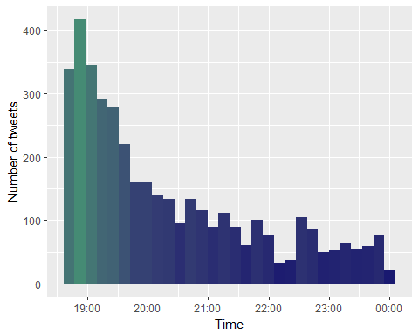

# plot tweets by source system (android, iphone, web, etc)  
tweets_all.df$tweetSource = sapply(tweets_all.df$statusSource,  
 function(sourceSystem) enodeSource(sourceSystem))  
  
  
ggplot(tweets_all.df[tweets_all.df$tweetSource != 'others',], aes(tweetSource)) +  
 geom_bar(fill = "aquamarine4") +   
 theme(legend.position="none",   
 axis.title.x = element_blank(),   
 axis.text.x = element_text(angle = 45, hjust = 1)) +  
 ylab("Number of tweets") +   
 ggtitle("Tweets by Source")

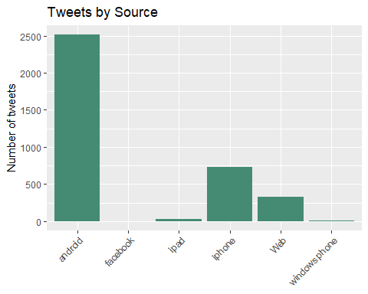

###################################################################################################################################  
#Build document matrix table containing the frequency of the words.  
#Column names are words and row names are documents.  
###################################################################################################################################  
#Document matrix table  
tweets_2 <- TermDocumentMatrix(tweets_text_corpus)  
tweets_2 <- as.matrix(tweets_2)  
tweets_2 <- sort(rowSums(tweets_2),decreasing=TRUE)  
  
#Converting words to dataframe  
tweets_2 <- data.frame(word = names(tweets_2),freq=tweets_2)  
  
#The frequency table of words  
head(tweets_2, 10)

## word freq  
## savejpwishtown savejpwishtown 412  
## will will 362  
## bahadur bahadur 339  
## sher sher 339  
## shri shri 299  
## deuba deuba 282  
## sir sir 281  
## foundation foundation 278  
## day day 257  
## hon hon 256

#Word frequencies Plot for the first 10 frequent words  
barplot(tweets_2[1:50,]$freq, las = 2, names.arg = tweets_2[1:50,]$word,col ="blue",   
 main ="Most frequent words",ylab = "Word frequencies")

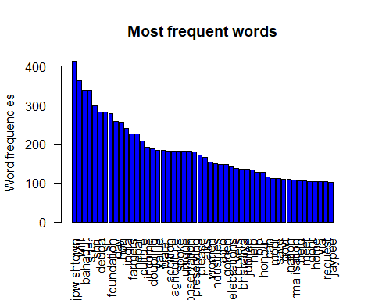

###################################################################################################################################  
# Word Cloud  
###################################################################################################################################  
set.seed(16702)  
wordcloud(tweets_text_corpus,min.freq=1,max.words=80,scale=c(2.2,1),   
 colors=brewer.pal(8, "Dark2"), random.color=T, random.order=F)

## Warning in wordcloud(tweets_text_corpus, min.freq = 1, max.words = 80,  
## scale = c(2.2, : ssccglnormalisation could not be fit on page. It will not  
## be plotted.

## Warning in wordcloud(tweets_text_corpus, min.freq = 1, max.words = 80,  
## scale = c(2.2, : country could not be fit on page. It will not be plotted.

## Warning in wordcloud(tweets_text_corpus, min.freq = 1, max.words = 80,  
## scale = c(2.2, : pictures could not be fit on page. It will not be plotted.

## Warning in wordcloud(tweets_text_corpus, min.freq = 1, max.words = 80,  
## scale = c(2.2, : sacrifice could not be fit on page. It will not be  
## plotted.

## Warning in wordcloud(tweets_text_corpus, min.freq = 1, max.words = 80,  
## scale = c(2.2, : childrens could not be fit on page. It will not be  
## plotted.

## Warning in wordcloud(tweets_text_corpus, min.freq = 1, max.words = 80,  
## scale = c(2.2, : president could not be fit on page. It will not be  
## plotted.

## Warning in wordcloud(tweets_text_corpus, min.freq = 1, max.words = 80,  
## scale = c(2.2, : sharing could not be fit on page. It will not be plotted.

## Warning in wordcloud(tweets_text_corpus, min.freq = 1, max.words = 80,  
## scale = c(2.2, : celebrating could not be fit on page. It will not be  
## plotted.

## Warning in wordcloud(tweets_text_corpus, min.freq = 1, max.words = 80,  
## scale = c(2.2, : ramrahimverdict could not be fit on page. It will not be  
## plotted.

## Warning in wordcloud(tweets_text_corpus, min.freq = 1, max.words = 80,  
## scale = c(2.2, : homage could not be fit on page. It will not be plotted.

## Warning in wordcloud(tweets_text_corpus, min.freq = 1, max.words = 80,  
## scale = c(2.2, : people could not be fit on page. It will not be plotted.

## Warning in wordcloud(tweets_text_corpus, min.freq = 1, max.words = 80,  
## scale = c(2.2, : remarks could not be fit on page. It will not be plotted.

## Warning in wordcloud(tweets_text_corpus, min.freq = 1, max.words = 80,  
## scale = c(2.2, : must could not be fit on page. It will not be plotted.

## Warning in wordcloud(tweets_text_corpus, min.freq = 1, max.words = 80,  
## scale = c(2.2, : need could not be fit on page. It will not be plotted.

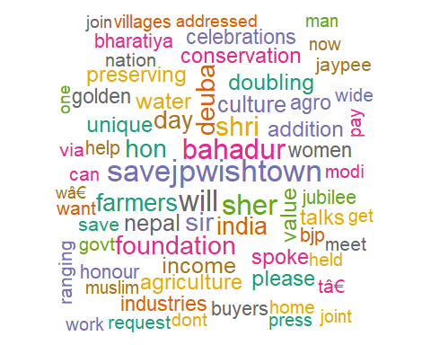

###################################################################################################################################  
#Sentiment Analysis - very positive, positive, negative, very negative and   
#neutral  
###################################################################################################################################  
#Get Tweet sentiment using syuzhet package  
tweetSentiments <- get_sentiment (tweets_all.df$text,method = "syuzhet")  
tweets <- cbind(tweets_all.df, tweetSentiments)  
tweets$sentiment <- sapply(tweets$tweetSentiments,encodeSentiment)  
  
# table data for tweet sentiments  
table(tweets$sentiment)

##   
## negative neutral positive very negative very positive   
## 219 976 384 515 1906

# visualization  
qplot(tweets$tweetSentiments) + theme(legend.position="none")+  
 xlab("Sentiment Score") +  
 ylab("Number of tweets") +   
 ggtitle("Tweets by Sentiment Score")

## `stat_bin()` using `bins = 30`. Pick better value with `binwidth`.

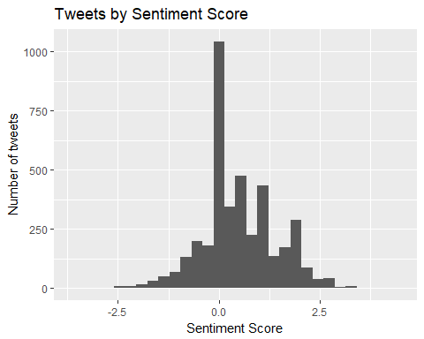

ggplot(tweets, aes(sentiment)) +  
 geom_bar(fill = "aquamarine4") +   
 theme(legend.position="none", axis.title.x = element_blank()) +  
 ylab("Number of tweets") +   
 ggtitle("Tweets by Sentiment")

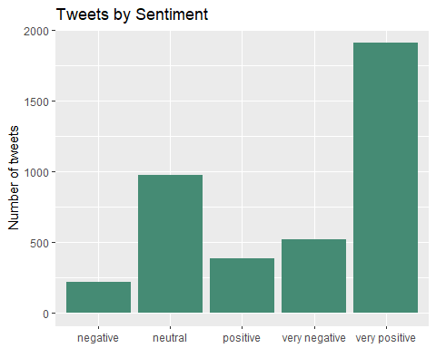

###################################################################################################################################  
# Get Emotions and Valence from NRC Dictionary. the emotions are :  
# "anger", "anticipation", "disgust", "fear", "joy", "sadness", "surprise",   
# "trust", "negative", "positive."  
###################################################################################################################################  
tweetSentiments <- get_nrc_sentiment(tweets_all.df$text)  
tweets <- cbind(tweets_all.df, tweetSentiments)  
  
# Take out the emotions  
sentimentTotals <- data.frame(colSums(tweets[,c(18:27)]))  
  
names(sentimentTotals) <- "count"  
sentimentTotals <- cbind("sentiment" = rownames(sentimentTotals), sentimentTotals)  
rownames(sentimentTotals) <- NULL  
  
#Emotions count table   
sentimentTotals

## sentiment count  
## 1 anger 612  
## 2 anticipation 1664  
## 3 disgust 438  
## 4 fear 745  
## 5 joy 1664  
## 6 sadness 874  
## 7 surprise 862  
## 8 trust 2629  
## 9 negative 1818  
## 10 positive 4584

# Visualization  
ggplot(data = sentimentTotals, aes(x = sentiment, y = count)) +  
 geom_bar(aes(fill = sentiment), stat = "identity") +  
 theme(legend.position = "none") +  
 xlab("Sentiment") + ylab("Total Count") + ggtitle("Total Sentiment Score for All Tweets")

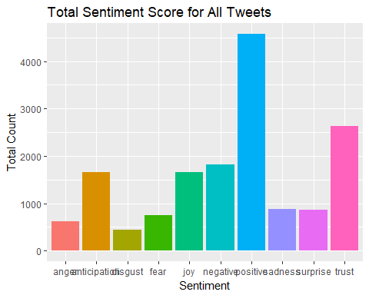

###################################################################################################################################  
# Interpretation  
###################################################################################################################################  
# MAximum tweets where through android OS, stating source was mostly android based pj=hone or laptop/computer   
# We analysed 4000 tweets where most of the tweets scored near '0' (neutral) or more (positive)  
# 'savejpwishtown' tops the list of frequent words owing to Jaypee builders bankrupcy  
# Few words like 'will', 'can' made it to the list but are not helpful  
# Very Positive (47.65%) and neutral (24.4%) tweets have got more share compared to other sentiments  
# Emotions like 'anticipation', 'joy', 'trust' lead the chart for sentiments.